$$Φ=hf_{0}$$

$${KE}_{max}=qV_{0}$$

LED’s:

|  |  |
| --- | --- |
| Pros: | Cons: |
| Much more energy efficient than older light sources. | Harder to use with dimmers. |
| Much longer lifespan. | Tend to decrease in brightness over their lifespan. |
| Less wasted heat. | Can fail prematurely in high temperatures. |
| More physically durable. |  |
| Increasingly affordable. |  |
| Good at directional light. |  |

Summary:

|  |  |
| --- | --- |
| LED’s: | Photovoltaic cells: |
| n-type semiconductor contains trapped, excited electrons. | Electric field naturally occurring in the n-p junction would push the electrons from the p-type semiconductor to the n-type semiconductor. |
| p-type semiconductor contains holes that the electrons can relax into. | p-type semiconductor doesn’t contain electrons in the conduction band where they could move so no current flows. |
| Electric field naturally occurring in the n-p junction prevents electrons and holes recombining. | Incident light excites the valence band electron in the p-type junction to the conduction band where it can move. |
| External voltage can push the excited electrons against the field, allowing them to relax and emit light based on the band gap. | Electron current flows from the p-type to the n-type junction by the electric field. |

Would this be sufficient to explain why the photoelectric effect supports the particle model of light:

1. There’s a threshold frequency that determines whether or not a photocurrent will flow, supporting the particle model of light. Each photon carries a discrete amount of energy (E=hf) that an orbiting electron can use to ionise.
2. If the incident light has a frequency below the threshold frequency, no photocurrent will flow regardless of how long it’s left incident, supporting the particle model of light. The wave model predicts that it should emit photoelectrons if left incident for long enough as waves are a form of continuous transfer.
3. There’s no time delay between when the photon strikes the metal surface and when the photoelectron is emitted, supporting the particle model of light. The wave model predicts that there should be a time delay as the energy from the wave builds up over time.

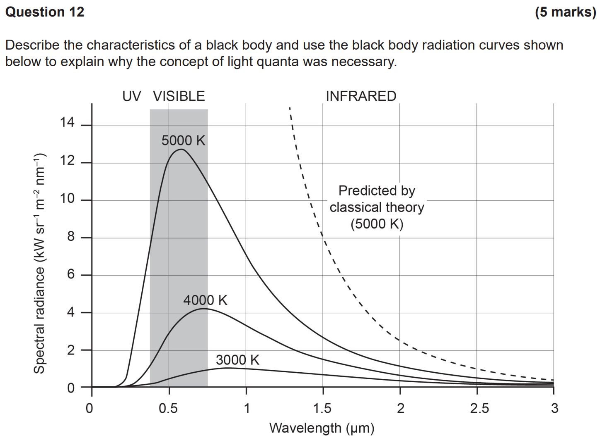

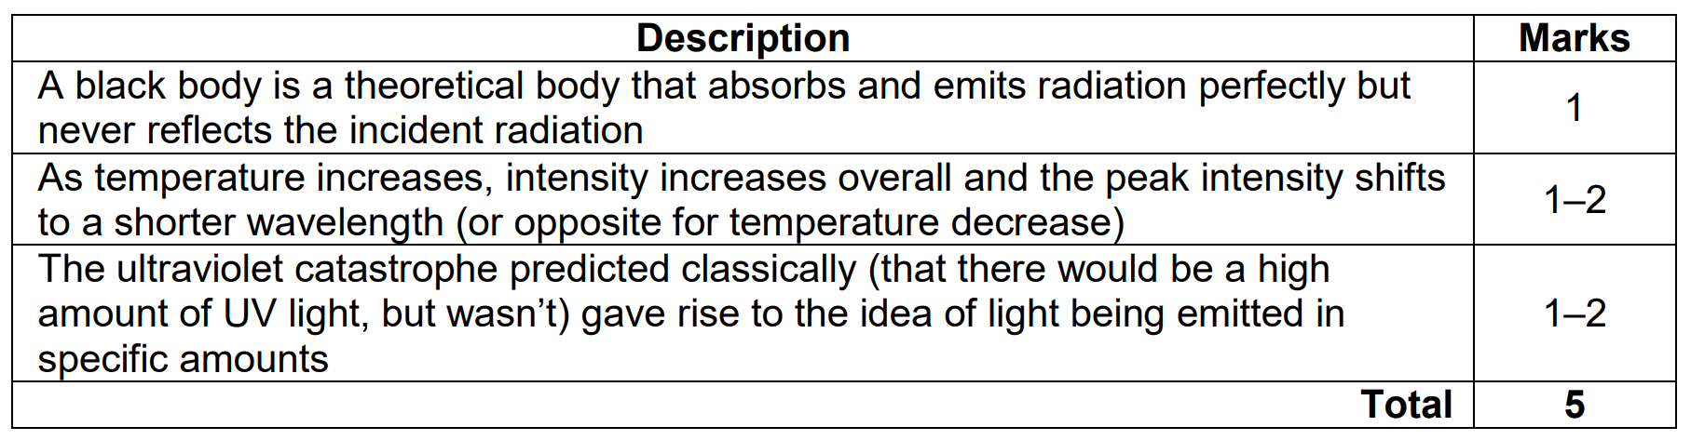

A blackbody is a theoretical ideal object that absorbs and emits all wavelengths of light without any reflection.

Classical theory predicted that all wavelengths would contain the same amount of energy and that emission was due to electric oscillators vibrating at the fundamental and higher frequencies. As the frequency increases, more energy would be emitted up to an infinite frequency which would result in an infinite energy at short wavelengths.

Quantum theory however showed that the higher frequencies would contain more energy than the low frequencies as E=hf and hence less photons would be emitted to achieve the same energy output.

Classical theory: If each wavelength is of equal energy, then as frequency increases to infinity, the energy increases to infinity.

Quantum theory: If each wavelength is of different energy, then as frequency increases to infinity, there are less photons to give the same energy output.

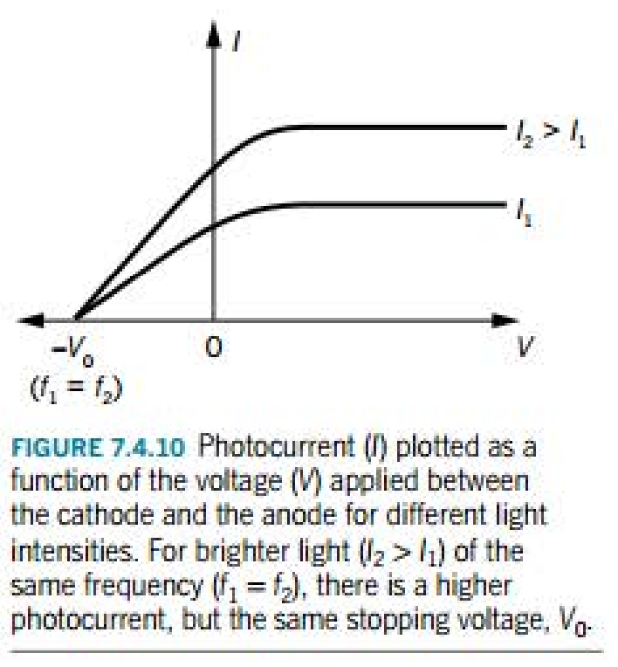

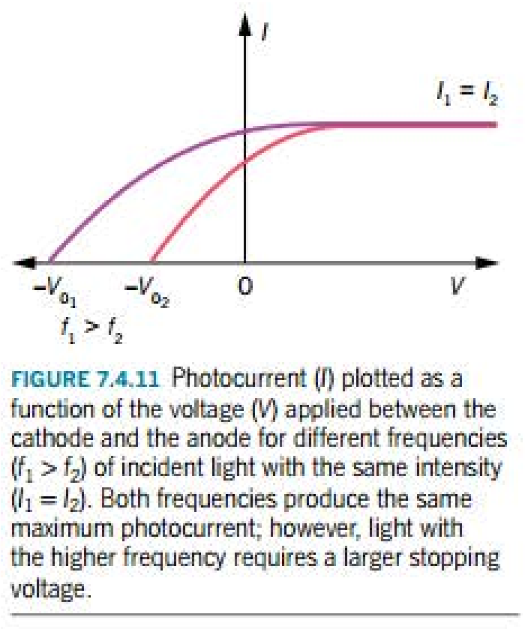

Rules:

1. Increasing frequency increases stopping voltage (moves to the left) but doesn’t affect the maximum intensity.
2. Increasing intensity increases the photocurrent (moves upwards) but doesn’t affect the stopping voltage.

**Quantum Theory**

Radiation:

* All objects at a temperature above 0K emit electromagnetic radiation.
* At room temperature, most of this radiation is in the infrared part of the electromagnetic spectrum.
* As temperature increases, the amount of emitted radiation increases and a higher proportion of it is in the visible part of the electromagnetic spectrum.
* As temperature increases, the proportion of the electromagnetic radiation emitted in the visible spectrum increases and more of the energy is radiated at shorter wavelengths.
* At ~3000K, a significant amount of energy is emitted as red wavelengths of the visible spectrum and so the object appears red.
* At ~6000K, energy is radiated roughly evenly across different wavelengths of the visible spectrum so the object appears white.
* At ~12000K, more of the energy is being radiated in the UV and violet parts of the visible spectrum and so the object appears blue.
* The shape of the emission spectrum depends on the material and the temperature but an ideal blackbody emits a radiation spectrum that only depends on its temperature.

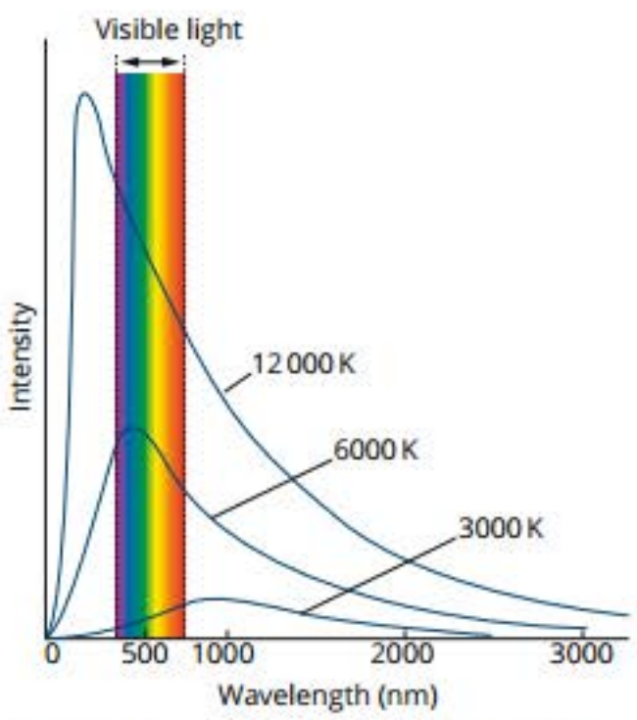

Blackbody radiation:

* A blackbody is an ideal absorber and absorbs all incident radiation.
* It’s in equilibrium with its surroundings as it radiates and absorbs energy at the same rate → its temperature remains constant.
* A blackbody can be approximated by the inside of a cavity with a small entrance hole since all incident light entering the hole is trapped.
* The shape of the radiation spectrum only depends on temperature.

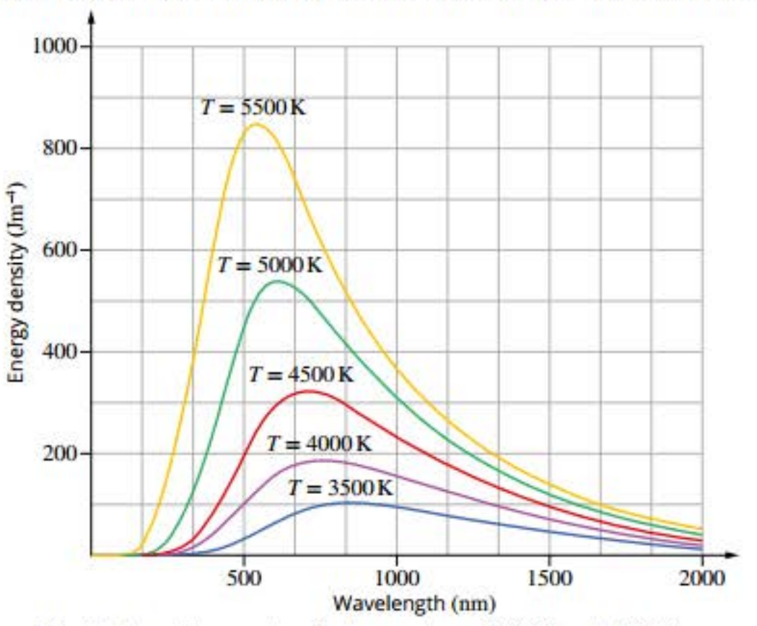

Increasing temperature means:

* Peak energy density increases.
* Total energy emitted (area under the curve) increases.
* Wavelength of the peak energy density decreases.
* Frequency of the peak energy density increases.
* Wien’s displacement law: $λ_{max}T=0.2898 x {10}^{-2}mK$.
* ${λ_{max}}_{1}T_{1}={λ_{max}}_{2}T_{2}$.

UV Catastrophe:

* Classically, thermal radiation is emitted by accelerating charges near the surface of a material.
* The charges have a distribution of accelerations, resulting in a range of thermal energies.
* The classical expression called the Rayleigh-Jeans Law gives the average energy per oscillating or vibrating charge proportional to temperature.
* The radiated energy can be considered to be produced by standing waves or resonant modes within the cavity.
* At long wavelengths there’s reasonable agreement between the experimental and calculated data.

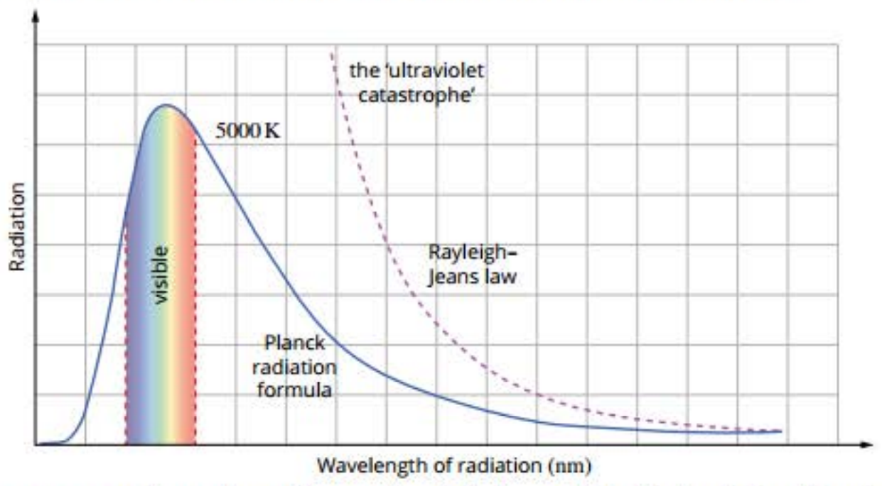

* As wavelength decreases, the radiation continues to get larger, approaching infinity – this is known as the UV catastrophe.
* To get theory to match experimental observations, Planck incorporated 2 fundamental postulates:

1. Molecules vibrate at discrete energies or frequencies ($E_{n}=nhf$).
2. Molecules emit and absorb radiation in discrete packets called photons. To gain energy, a molecule absorbs a photon (upwards arrow) and to lose energy it emits a photon (downwards arrow).

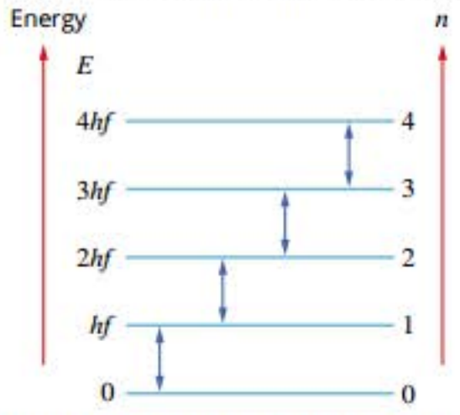

Electron-volt:

* To convert from J to eV, divide by 1.6 x 10-19.
* To convert from eV to J, multiply by 1.6 x 10-19.
* eV > J.

Photoelectric effect:

* When some types of electromagnetic radiation are incident on a piece of metal, the metal becomes positively charged due to electrons being ejected from the surface. This phenomenon is called the photoelectric effect.
* These electrons are called photoelectrons because they’re released due to light or other forms of electromagnetic radiation.
* To observe the photoelectric effect, a clean metal surface (cathode) is illuminated with light from an external source. If the light causes photoelectrons to be emitted, they’re detected at the anode.
* The flow of electrons is called the photocurrent and is registered by a sensitive ammeter.

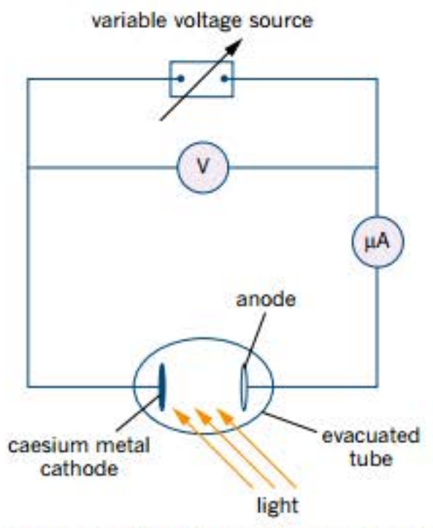

* A forward voltage/forward bias is created when the cathode is negative and the anode is positive. In this case the photoelectrons will accelerate towards the anode by the electric field, creating a photocurrent in the circuit.
* A reverse voltage/reverse bias is created when the cathode is positive and the anode is negative. In this case the photoelectrons will be repelled by the anode, and this slows them down. As the anode voltage increases, the photoelectrons are repelled more and more until the photocurrent drops to zero.
* Lenard used a filter to vary the frequency of the incident light.
* For a particular cathode metal, there’s a threshold frequency (f0) below which no photoelectrons are observed.
* For frequencies above the threshold frequency, the rate at which the photoelectrons are produced is proportional to the intensity (brightness) of the incident light.

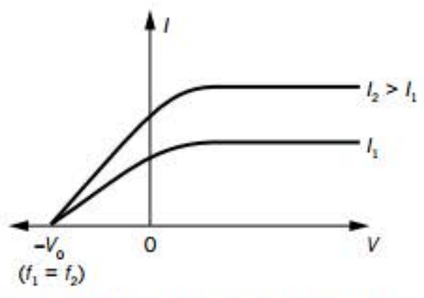

Features of the photoelectric effect:

* As the light intensity increases, the photocurrent increases.
* At 0V there’s still a photocurrent due to the kinetic energy of the photoelectrons.
* When the applied voltage is positive, photoelectrons are attracted to the anode.
* When the applied voltage is negative, the cathode is positive and thus photoelectrons are repelled by the anode and the photocurrent is reduced. As the reverse bias becomes more negative, the photocurrent decreases as less photoelectrons have the kinetic energy to overcome the opposing electric potential. There’s a stopping voltage (V0) for which no photoelectrons reach the anode. For a particular metal, each frequency of light will give a characteristic stopping voltage. This value is independent of light intensity.
* Since the stopping voltage is large enough to stop even the fastest moving electrons from reaching the anode, $W=V_{0}q$ gives the maximum possible kinetic energy of the emitted photoelectrons.
${KE}_{max}=W=V_{0}q$

* When light intensity is kept constant but frequency is varied (above the threshold frequency), the maximum current remains the same but the higher frequency has a higher V0.

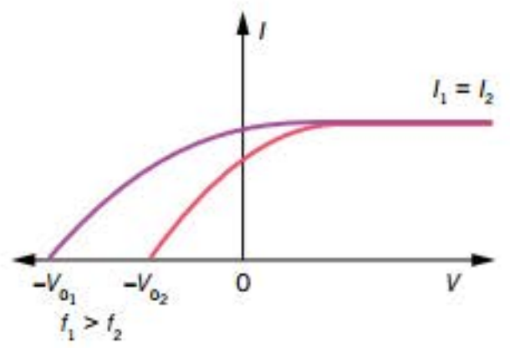

* There’s no time delay between the light striking the metal and the photoelectrons being emitted regardless of the light intensity and frequency (given it’s above the threshold frequency).
* With incident light above the threshold frequency, electrons with the maximum kinetic energy are usually emitted from the first layer of atoms at the surface of the metal and are the least tightly bound.
* Other photoelectrons come from deeper inside the metal and lose some of their kinetic energy due to collisions on their way to the surface. Thus, the emitted photoelectrons have a range of kinetic energies.

Explaining the photoelectric effect:

|  |  |
| --- | --- |
| Particle theory: | Wave theory: |
| * Frequency should affect whether photoelectrons are ejected. * There’s a threshold frequency below which no photoelectrons will be emitted regardless of how long the light is left incident on the metal. * There isn’t a time delay between the light striking the metal and photoelectrons being emitted. | * Frequency shouldn’t affect whether photoelectrons are ejected. * Since waves are a form of continuous energy transfer, even a low-frequency light should transfer enough energy to emit photoelectrons if left incident on the metal for long enough. * There should be a time delay between the light striking the metal and photoelectrons being emitted as the energy from the wave builds up in the metal over time. |

Einstein and the photoelectric effect:

* Einstein assumed that light exists as particles or photons each with an energy $E=hf$.
* For a particular metal, the amount of energy required to eject one photoelectron (work function (Φ)) is a constant value that depends on the strength of the bonding within the metal.
* Shining light on the surface of a metal is equivalent to bombarding it with photons. When a single photon interacts with a single electron, it transfers all of its energy at once to the electron.
* If the energy of the photon is less than the work function, the photoelectrons won’t be released as the electrons won’t gain enough energy to let them break free of the metal atoms.

Kinetic energy of photoelectrons:

* If the energy of the photon is greater than the work function of the metal, a photoelectron is released.
* The remainder of the energy is transformed into the kinetic energy of the photoelectron.

${KE}_{max}=hf-Φ$

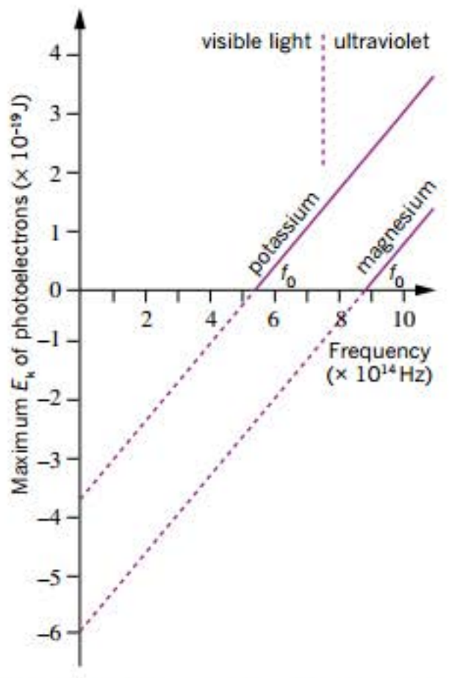

* The threshold frequency is shown by the x-intercept (where ${KE}_{max}=0$).
* At the threshold frequency, electrons are no longer bound to the metal but they have no kinetic energy.
* The greater the frequency (and hence energy) of the light, given it’s above the threshold frequency, the greater the kinetic energy of the photoelectron.

Resistance to the quantum model of light:

Photons:

* Photons come into existence when energy is released from an atom.
* Each orbital can accept only a discrete amount of energy.
* If an atom absorbs some energy, an electron in an orbital close to the nucleus (a lower energy level) can jump to an orbital that’s farther away from the nucleus (a higher energy level). The atom is now said to be excited.
* This excitement generally doesn’t last very long and the electron falls back into the lower energy level. A packet of energy called a photon is released.
* The emitted energy is equal to the difference between the high and low energy levels and, depending on its frequency, might be seen as light.

Waves:

* The wave form of light can be understood as energy that’s created by an accelerating or oscillating charge. This produces an oscillating electric field and an oscillating magnetic field, hence the name electromagnetic radiation.
* The 2 fields oscillate perpendicular to each other.
* Light is only one form of electromagnetic radiation. All forms are classified on the electromagnetic spectrum by their frequency.

Electromagnetic radiation:



Properties of light and electromagnetic radiation:

* Light travels in straight lines. It can travel through a vacuum or transparent media.
* Speed of light in a vacuum is 3 x 108ms-1. This is a maximum speed.
* Light travels at different speeds in different media. This can cause refraction.
* Surfaces reflect light. Angle of incidence = angle of reflection.
* Light diffracts when travelling through narrow openings or around the edge of a barrier.
* Light creates interference patterns in a similar manner to water waves.
* Light can cause electrons to be ejected from some metal surfaces.

Summary:

* Light exhibits many wave properties, but it can’t be modelled only as a mechanical wave because it can travel through a vacuum.
* Current understanding of the nature of electromagnetic radiation states that electromagnetic radiation has both wave and particle characteristics.
* Low-energy electromagnetic radiation seems to be the most noticeably wavelike and high-energy the most noticeably particle-like.
* A particle of electromagnetic radiation is called a photon – a discrete amount of energy called a quantum of energy.
* Each photon of energy has its own characteristic frequency (E = hf).
* Oscillating charges produce electromagnetic waves of the same frequency as the oscillation. Electromagnetic waves cause charges to oscillate at the frequency of the wave.

Reflection: When the wave bounces off a surface.

Refraction: When waves bend as they pass from one medium to another. The change in direction is caused by a change in the speed of the wave as it enters a new medium.

Diffraction: When a wave passes through a narrow opening (aperture). The greatest diffraction results when the width of the opening that the wave passes through is similar to the wavelength of the wave. Diffraction also occurs at the edges of an obstacle. In this case, waves of greater wavelength tend to diffract more noticeably.

Polarisation:

* Oscillation of light’s electric and magnetic fields are always perpendicular to the direction of oscillation (transverse wave) but they can be at any rotation.
* Light can be filtered to only allow light of a specific orientation through.
* Most intuitively explained by light as a wave (specifically a transverse wave) but quantum mechanics relates polarisation to photon spin, allowing for a particle interpretation.

Blackbody radiation:

* All objects with a temperature above 0K emit energy as electromagnetic radiation.
* A blackbody is a theoretical ideal object that absorbs and emits all frequencies of electromagnetic radiation “perfectly”.
* It’s useful to model the behaviour of stars and planets as blackbodies.

Blackbody radiation spectrum:

* Blackbody radiation is always a range of different frequencies.
* The intensity of different frequencies varies only with temperature.
* As the temperature of the blackbody increases, the dominant wavelength emitted decreases and hence the dominant frequency increases.
* This is why heated objects glow red → white → blue.
* The total energy emitted (area under the curve) increases dramatically with temperature.
* Classical theories (black) couldn’t match the empirical evidence (red, green and blue) – intensity of light emitted approaches infinity as wavelength approaches 0 – UV catastrophe.

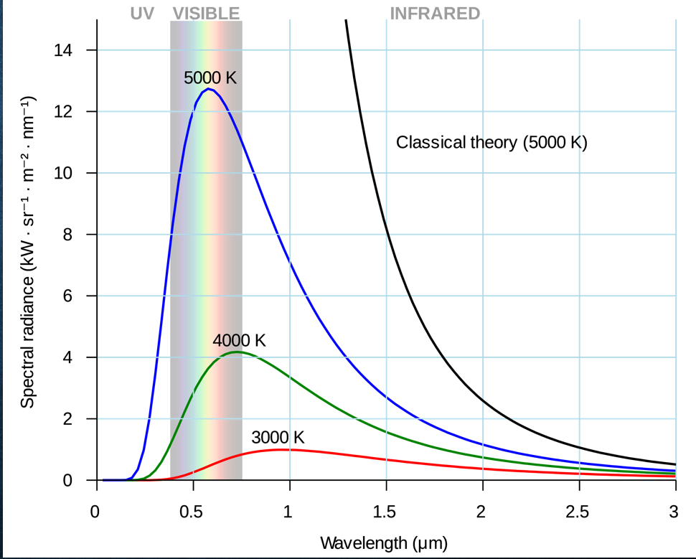

**Set 12.1**

**Q: What’s meant by stating that light is transmitted as an electromagnetic wave?**

Light can be modelled by coupled transverse waves, one a magnetic field and the other an electric field perpendicular to each other that move forwards by creating each form the other at the speed of light.

**Q: 2 light sources are described as coherent. What does this mean?**

The light sources are of the same frequency and are in phase.

**Q: Would the light from 2 identical incandescent lamps be coherent? Explain.**

No because they are producing more than one frequency of EM radiation. Coherent light must be monochromatic, as even if the light sources produced the same range of frequencies, there is no reason why both sources will produce the same frequency at the same time.

**Q: The energy of an electron depends on its velocity. All photons in the air have the same velocity. How is it that photons in the visible spectrum with different colours can have different energies?`**

According to the formula E = hf the energy of a photon is reliant not on the velocity of the photon, but on its frequency. Different colours of light correspond to photons of different frequencies, and therefore, according to E = hf, different energies.

**Q: TV antennas are mounted in the horizontal and not the vertical plane. Explain.**

Antennas need to be mounted in an orientation that corresponds to the method of polarisation the waves they’re receiving have been subject to. Horizontal antennas are placed to receive TV signals as the TV signals are horizontally polarised themselves.

**Q: Why is green light used instead of infrared laser to determine water depth in oceans?**

Green light has a higher frequency which means it’s less likely to interact with the molecules on the way through the water.

**Q: Why does a beam of green light used to calculate water depth in oceans need to have a high intensity and what’s meant by “high intensity”?**

High intensity means the beam consists of many photons. It needs a high intensity because photons may scatter due to collisions with water molecules. The more photons, the more photons that will successfully be reflected back.

**Q: Explain why the temperature of a yellow incandescent globe will increase.**

Incandescent globes only emit a small portion of energy supplied as visible light. A large portion of the energy supplied is radiated as heat.

**Q: Draw a graph of what you think the distribution of blackbody radiation from this globe would look lie.**

The blackbody curve should have its peak in the UV part of the spectrum.

**Q: Why wouldn’t it be possible to determine the number of photons from experimental measurement?**

It would be hard to determine the number of photons from experimental measure because the photons aren’t travelling in a beam towards a detector like a laser, but radially. This is impractical to detect since they can travel in any direction.

**Photoelectric Effect**

Photoelectric effect: The process of emission of electrons from a metal surface when that surface is irradiated with light in the range from infrared to ultraviolet. It’s classified as a low-energy phenomenon.

Experimental evidence shows:

1. For photoelectrons to be emitted from a metal surface, there’s a minimum frequency (energy) needed in the incident radiation below which no photoelectric emission will occur, called the threshold frequency.
2. The kinetic energy of the emitted photoelectrons is independent of the intensity of the incident light.
3. An increase in intensity of the incident radiation causes more photoelectrons to be emitted. The photoelectric current is directly proportional to the intensity of the incident light provided its frequency is above the threshold frequency.
4. The higher the frequency of the incident radiation above the threshold frequency, the greater the number of photoelectrons emitted.
5. When a negative voltage was applied to the collector electrode, the current was reduced. At the stopping voltage there’s no current.
6. The stopping voltage varied for different metals and depended on light frequency. Light intensity, similarly to the first point, had no effect on stopping voltage.

The results of the photoelectric effect can’t be explained by the wave theory of light because:

* The wave theory predicts that the photoelectric effect would occur at any frequency given light of sufficient intensity. This would occur, given wave energy to be continuous and additive. However, this isn’t the case.
* The existence of threshold frequencies wasn’t able to be explained using wave theory.
* The wave theory predicts that an increase in the intensity of the light source would result in an increase in the kinetic energy of the photoelectrons. This isn’t the case as there was only an increase in the number of photoelectrons ejected (photocurrent).

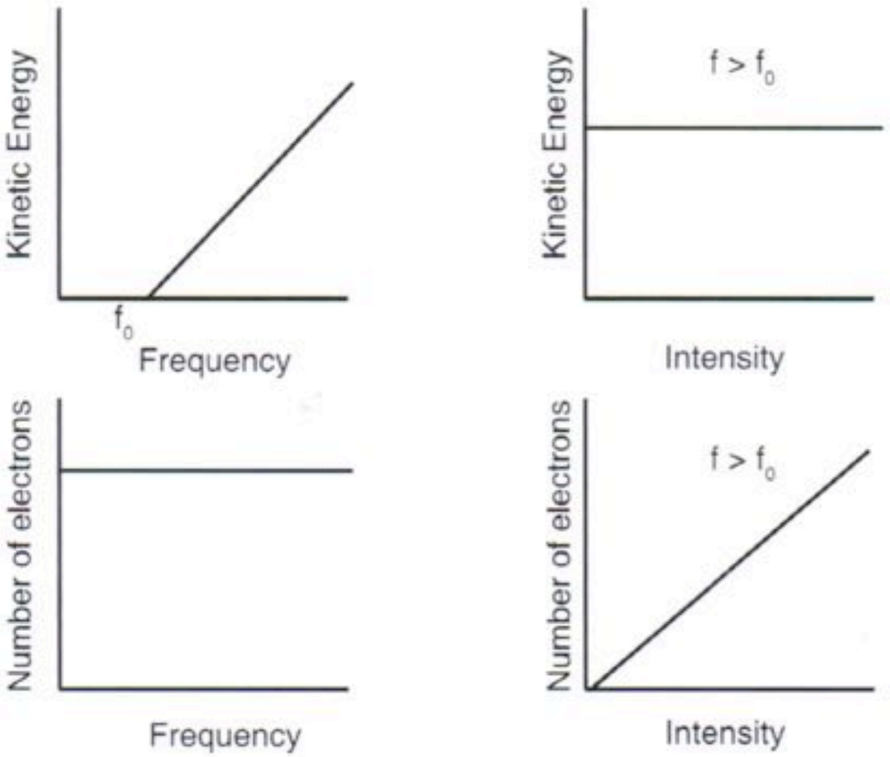

When individual photons hit a metal surface, all their energy is absorbed by an electron. If this photon energy is less than the work function of the metal, the electron is unable to escape. If it’s just equal to the work function, it will escape the surface but have no kinetic energy. Where the photon energy is greater than the work function, the escaping electron carries the excess energy as kinetic energy. Experimentally, this excess kinetic energy can be determined by measuring stopping voltage and applying W = Vq.

Ek = hf – W where:

* Ek is the maximum kinetic energy of the photoelectron.
* h is Planck’s constant.
* f is the frequency of the photon causing photoemission.
* W is the work function of the material emitting photoelectrons.

Work function: The minimum energy required of a photon incident on the metal surface to liberate an electron.

Factors that affect the emission of photoelectrons from a metal surface:

* The type of metal the surface is made from – different metals have different work functions which means there are differences in the threshold frequency.
* The wavelength of the incident light – Wavelength and frequency are inversely proportional (λ = $\frac{c}{f}$). Increasing the wavelength will cause a decrease in the frequency of the light. If this drops below the threshold frequency, no photoelectrons will be emitted.
* The intensity of the incident light – If the frequency is above the threshold frequency, a higher intensity will increase the photoelectron current. If the frequency is below the threshold frequency, no current will flow and changing the intensity won’t change this.
* The cleanliness of the surface – If the surface of the metal is covered (and the material is opaque) light won’t be able to strike the surface of the metal and the photoelectric effect won’t be observed.

Factors that don’t affect the emission of photoelectrons from a metal surface:

* The thickness of the piece of metal.
* The area of surface illuminated.
* The length of time for which the surface is illuminated.

Points to note:

* One photon will eject only one electron.
* A bright light has more photons than a dull light (not photons of higher energy).

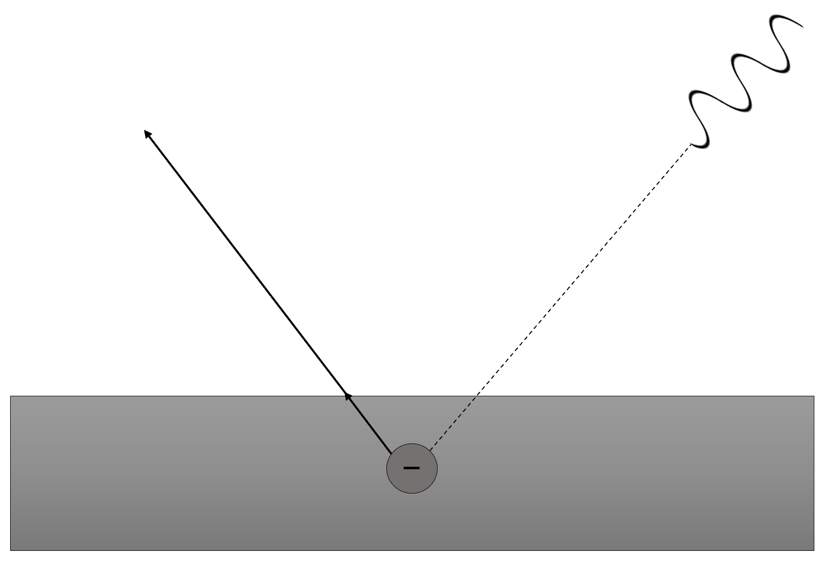

Photon of light (hf)

W

Metal

Ejected electron  
Ek = hf – W

Wave particle duality:

* Light interference patterns from diffraction support the wave-like nature of light.
* Photoelectric effect indicates a particle-like nature of light.
* Neither can be explained by both the wave or particle theory.

**Set 12.2**

**Q: Explain how the photoelectric effect is used as evidence for the particle nature of light.**

Firstly, the fact that there’s a threshold frequency which determined whether or not a photoelectron current would flow supported the idea that each quantum of light contains a certain amount of energy dependent on the frequency of the light. Secondly, the effect of increasing the intensity of the light on the photoelectron current when the light source is above the threshold frequency also supports the idea that the number of photons is related to the intensity.

**Q: A nickel surface, work function of 5.01eV, in an evacuated chamber is irradiated with light of wavelength 325nm.**

**[a] What stopping potential will prevent the emitted photoelectrons from travelling between the pair of plates in the chamber?**

No solution as the incident energy is below the work function.

**[b] The intensity of the incident light is doubled but the frequency remains constant. What effect will this have on the stopping potential?**

No effect. The stopping potential is related to the maximum kinetic energy of the electrons that are liberated. Doubling the intensity changes the amount of photoelectrons which are liberated, but not the energy of those electrons (this is related to increasing the frequency of the light). Therefore, there is no effect on the stopping potential.

**Q: An experiment is conducted where the surfaces of both platinum and sodium are irradiated with blue light of wavelength 465nm. Photoelectrons are found to be emitted from the sodium surface but not the platinum surface. Explain why this different has occurred with the 2 metal surfaces.**

In order for photoelectrons to be emitted from the surface the photons must have a minimum energy to dislodge them. The light must correspond to a frequency which is higher than the threshold frequency in sodium but not in the platinum.

**Q: Explain the effect that applying a small reverse potential between the anode and cathode of the photoelectric tube would have on the photoelectric current.**

Photoelectric current will decrease provided the incident beam is higher than the threshold frequency as a small reverse voltage will stop electrons with lower kinetic energy from moving.

**Q: One type of smoke detector contains a photocell, a device that reacts to the amount of light falling on it, and a small permanent light source. If some enters the detector, reducing the intensity of light falling on the photocell below a minimum value, the current change in the circuit will set off the alarm. How does the presence of smoke affect the emitted photoelectrons? Does it change their number or their energy or both?**

There’s no energy change but there’ll be a decrease in the number of photoelectrons (a decrease in current). The light source doesn’t change in frequency so the energy of the photons is constant throughout the entire process. The smoke, however, would cause photons to deflect from their path towards the photocell. This means less photons would interact with the electrons on the surface of the photocell, causing less photoelectrons to be emitted and thus the current would decrease.

**Quantum Theory**

Main points:

* Atomic phenomena and the interaction of light with matter indicate that states of matter and energy are quantised into discrete values.
* At the atomic level, the electromagnetic radiation is emitted or absorbed in discrete packets called photons.
* Atoms of an element emit and absorb specific wavelengths of light that are unique to that element.

c = f λ

E = hf = $\frac{hc}{λ}$

Ek = hf – W

ΔE = hf E2 – E1 = hf

λdB =

Atoms in their normal state may be excited by:

* Being heated (thermally excited).
* Being bombarded by fast-moving particles e.g., electrons.
* Absorbing photons of a specific frequency.

Principles of quantum mechanics:

1. Wave/particle duality – Experiments showed that light behaved as a wave. It bounces off walls and bends around corners, and crests and troughs of waves can add together or cancel out. Quantum theory revealed that light can sometimes behave as a particle.
2. Quantised properties – Properties e.g., energy, position and momentum are realised in specific, discrete quantities. This challenged the belief that such properties should exist on a smooth, continuous spectrum.
3. Matter waves – Matter can also behave as a wave. This was contrary to the understanding showing that matter exists as particles.

De Broglie proposed that the wave nature of the electron determined the allowed orbits in Bohr’s theory. He used a simple wave model to show that electron orbits must fit a whole number of wavelengths around the orbit. By doing this, they undergo constructive interference and are stable whereas the electron waves in non-allowed orbits undergo destructive interference and cancel out (third principle of quantum mechanics).

Deriving the De Broglie wavelength:

E = mc2

E = hf

mc2 = hf

mv2 = hf

mv2 =

λdB =

Electron transitions:

* The electron can only exist at certain energy levels.
* The ground state electron in a compound are in the lowest energy orbitals possible.
* When a photon is absorbed by the compound, an electron jumps from a low energy orbital to an unoccupied spot in a higher energy orbital – the compound is now said to be in an excited state.
* When an electron falls back to the vacant low energy orbital, a photon is released. The energy difference corresponds to the electromagnetic spectrum.

In their excited state, electrons remain in energy levels higher than their normal ground state for a very short time. When these electrons return to their ground state, they emit photons whose energy corresponds to the difference in energy levels.

There are many possible transitions and electrons may return to the ground state by a series of steps provided that there are energy levels in between. If atoms are sufficiently excited, a large number of electron transitions are possible leading to a corresponding number of lines in the observed emission spectrum for that substance.

Types of spectra:

* Emission spectra – Obtained by the dispersion of light coming directly from the source. This may be from the glowing gas in a discharge tube or an incandescent (glowing) solid e.g., a globe filament.
* Absorption spectra – Obtained by the dispersion of light that has passed through some absorbing material. We tend to see black lines superimposed onto a continuous spectrum which represents the absence of light within the spectrum.

Emission spectra may be either line, band or continuous emission:

* Line emission – If gaseous atoms are excited by fast-moving electrons (e.g., in a gas discharge tube), light of specific frequencies is emitted. When viewed through a spectroscope, there are distinct lines which are characteristic of the atoms of that element.
* Band emission – Due to the excitation of gaseous molecules (rather than atoms). High pressure glowing gas or salts in a flame will give bands of fine lines when viewed through a spectrometer.
* Continuous emission – When light from a hot incandescent solid is viewed through a spectroscope, a continuous spectrum is seen.

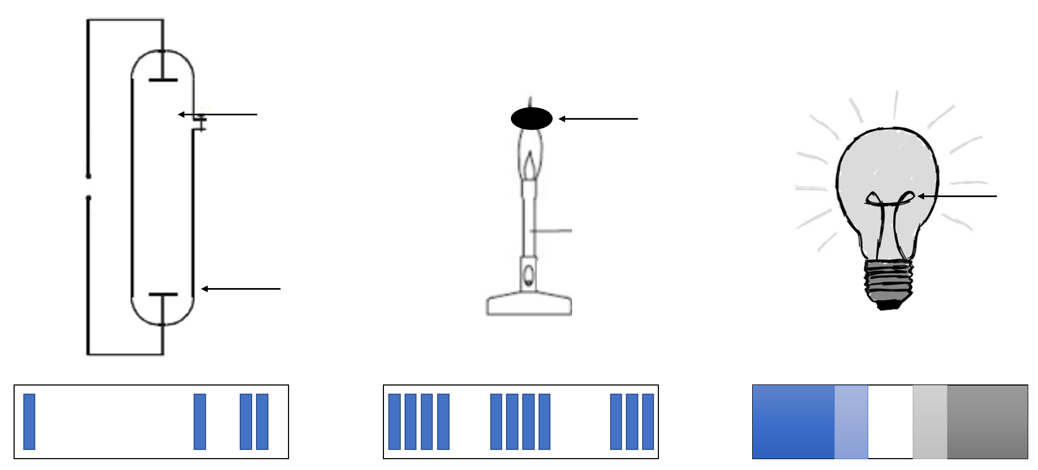

Salt sample

Incandescent solid

High voltage

Gas at low pressure

Discharge tube

Glowing filament

Salts placed in a flame

Continuous emission

Line emission

Band emission

Absorption spectra may be either line or band absorption:

* Line absorption – When white light is passed through a vapour or some low pressure gas, photons of the frequencies corresponding to the line emission spectrum of that gas will be absorbed. This means that black lines (absence of light) will be seen where bright lines would’ve appeared in an emission spectrum.
* Band absorption – Occurs in a similar manner to line absorption when light passes through coloured glass or coloured liquid solutions, Dark bands are visible within an otherwise continuous spectrum.

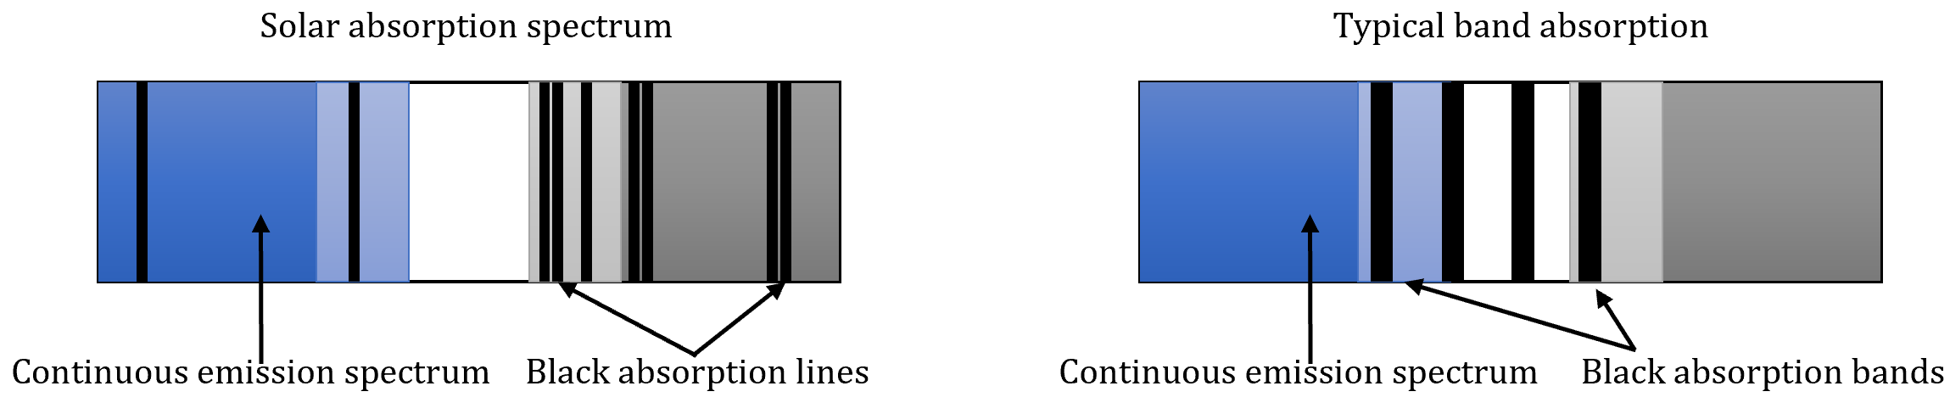

Fluorescence:

* Fluorescent materials can absorb UV light and re-emit it as visible light.
* This phenomenon relies on the energy levels of the atoms of the material.
* Examples:
* Fluorescent minerals.
* Fluorescent tubes.
* Fluorescent ink.

Band gaps in solids:

* In a solid, the energy levels of the many atoms combine to form allowable energy bands separated by forbidden gaps.
* For conduction to occur in solids, the electrons from the valence band must move up through an energy gap to the conduction band.
* In metals, this gap is very small and conduction occurs readily.
* Insulators have large band gaps which limit conduction.
* Semiconductors have relatively small band gaps and this allows their conducting properties to be readily modified by doping them with suitable impurity materials e.g., diodes (LEDs in particular).

LEDs:

* An LED is a chip of semiconducting material containing small amounts of impurities so as to create a p-n junction.
* When a small forward voltage is applied, it emits light from this junction.
* The colour of light produced depends on the particular combination of impurities used.
* These determine the energy gap of the semiconductor chip and hence the energy of the photons emitted.

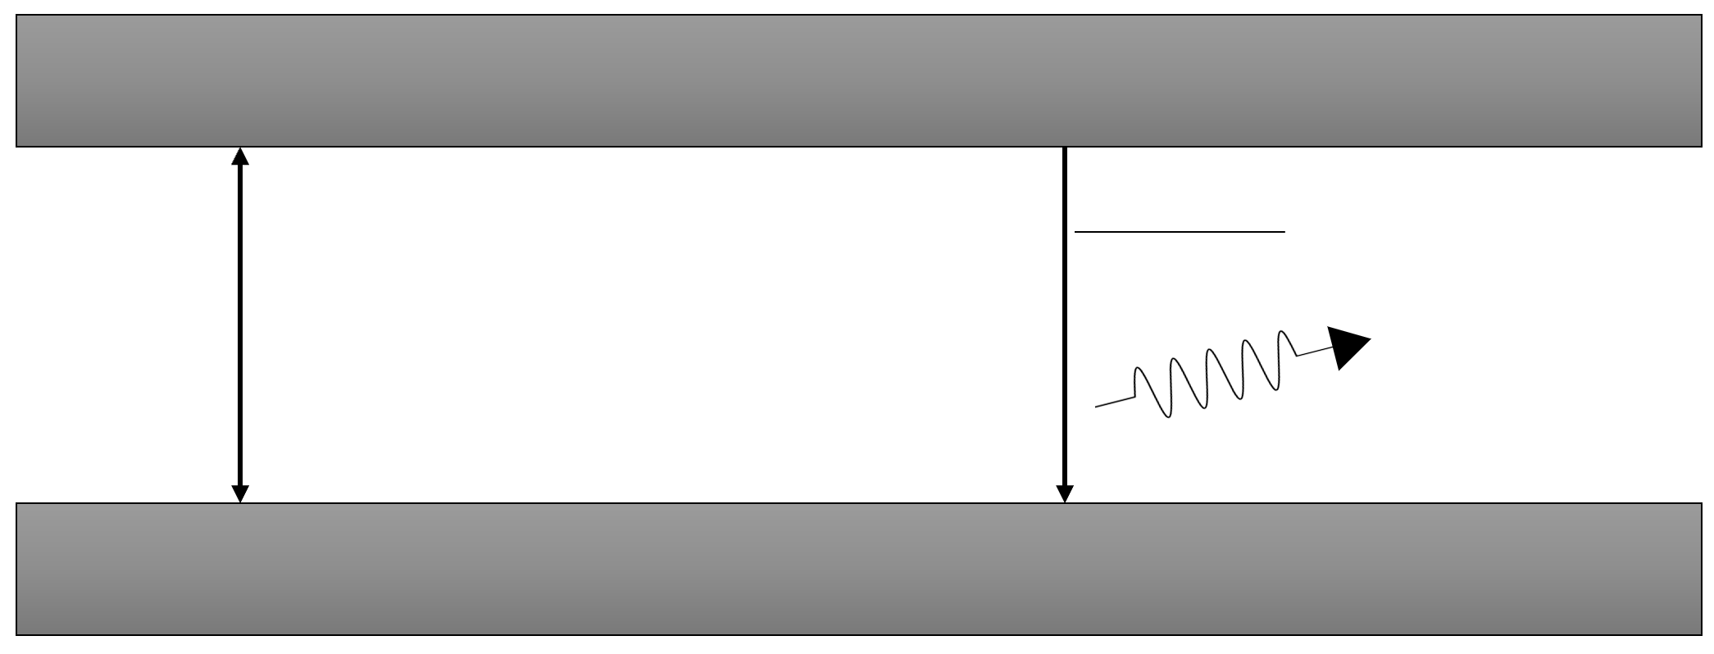

Energy gap (Eg)

Electron falls to  
valence band

Photon of light emitted

Valence band

Conducting band

E(photon) = E(high) – E(low)

f = $\frac{c}{λ}$ = $\frac{E}{h}$

E = hf = $\frac{hc}{λ}$

Emission of light by a hydrogen atom:

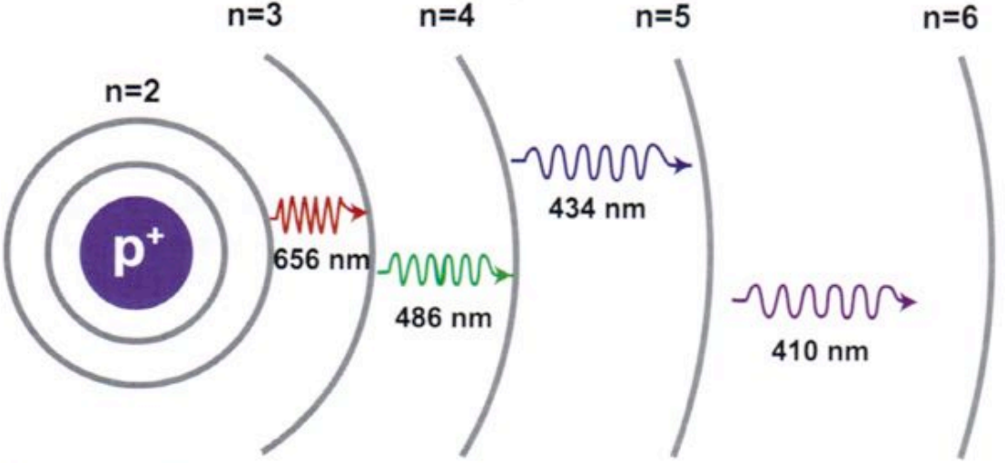

Hydrogen absorption spectrum (left) and emission spectrum (right):

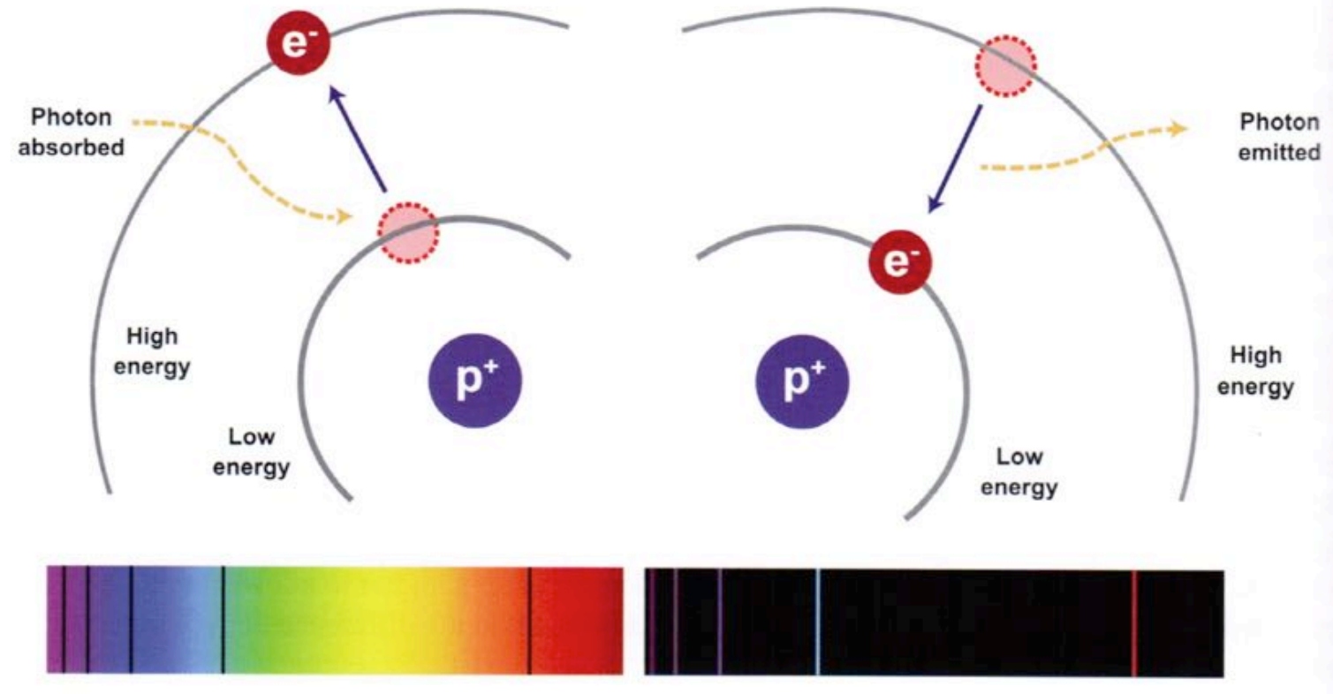

Production of X-rays:

* X-rays are high frequency electromagnetic waves/photons that are produced when high-speed electrons strike a metal target.
* They’re produced in an X-ray tube where:
* Electrons are accelerated to very high velocities by voltages of about 50kV.
* The electrons strike a metal target (usually tungsten) an cause very short wavelength photons to be emitted (around 10-11m).
* The electrons often undergo several collisions with the metal target while giving up their energy.
* Each collision results in some loss of energy which results in photons of that energy.
* Several photons of different energies are produced this way.
* An X-ray spectrum from an X-ray tube will also show characteristic peaks.
* Energetic incoming electrons will sometimes remove electrons from the lower energy levels of the target metal atoms.
* Electrons from higher levels within the atom quickly fall to the vacated orbital and consequently release high-energy photons (X-rays) of a specific frequency.

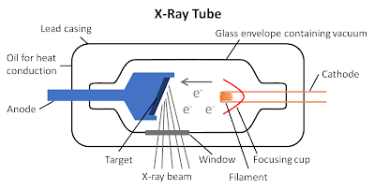

X-ray spectrum:*

X-ray intensity

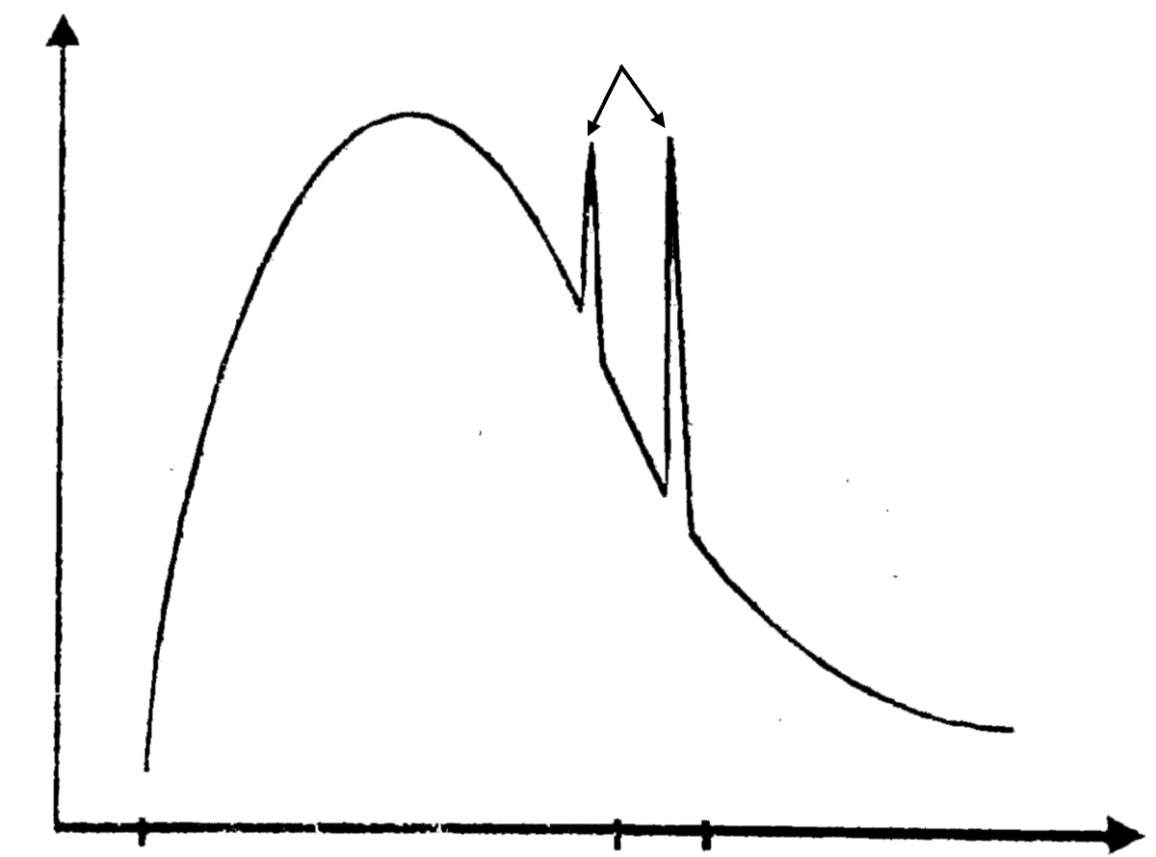

Characteristic peaks

Wavelength

**Set 13**

**Q: Explain how the black lines are formed in the emission spectrum of light from stars.**

When light travels through the elements and compounds in stars, photons of certain wavelengths are absorbed. The light from the star when viewed on Earth is therefore missing certain wavelengths, causing dark lines in the spectrum.

**Q: Explain how analysis of emission spectra gives accurate predictions for stars.**

Every absorption spectral line is also present in the emission spectra lines for a given element. By looking at the emission spectra for different elements in the lab, we can account for all the lines which are present in the absorption spectra of a star and hence deduce which elements are in the star.

**Q: What is the essential criterium needed to produce the line emission spectra?**

The substance must be at a high temperature.

**Q: Explain why the CrCl3 solution appears green when white light is incident on it?**

When white light is shone through the solution, the molecules absorb certain frequencies of light. As white light contains all colours of light, the green colour is what we perceive to be the combination of all colours in white light without the colours which were absorbed.

**Q: Explain why the spectrum from a gas only shows the emission of certain wavelengths on excitation and why this same gas can absorb only some of these wavelengths.**

Absorption spectra results when an electron in the ground state in the ground state gains energy and transitions to a higher energy level. Emission spectra are the result of electrons moving from a higher energy level to a lower one, including all transitions to the ground state. Hence, any absorption spectra line will be present in the emission spectra.

**Q: Gaseous helium has a first excitation energy of 21.2eV and an ionisation energy of 24.6eV.**

[a] What would you expect to occur to these gas atoms or to observe in the emitted spectrum if these incident electrons had an energy of 26.0eV? Explain.

There’d still be the same emission spectra as electrons can give a portion of their kinetic energy after a collision. We should expect to see ionised helium, however.

**[b] A beam of photons with a range of energies up to 26.0eV was incident on this sample of helium. How would the transmitted beam differ from this incident beam and what’s the maximum energy photon that might now be emitted?**

The transmitted beam would be missing photons of energy 21,2eV and anything equal to or above 24.6eV. There’s no change to the maximum photon which can be emitted as there’s still only one transmission downwards from the 21.2eV energy level to the ground state.

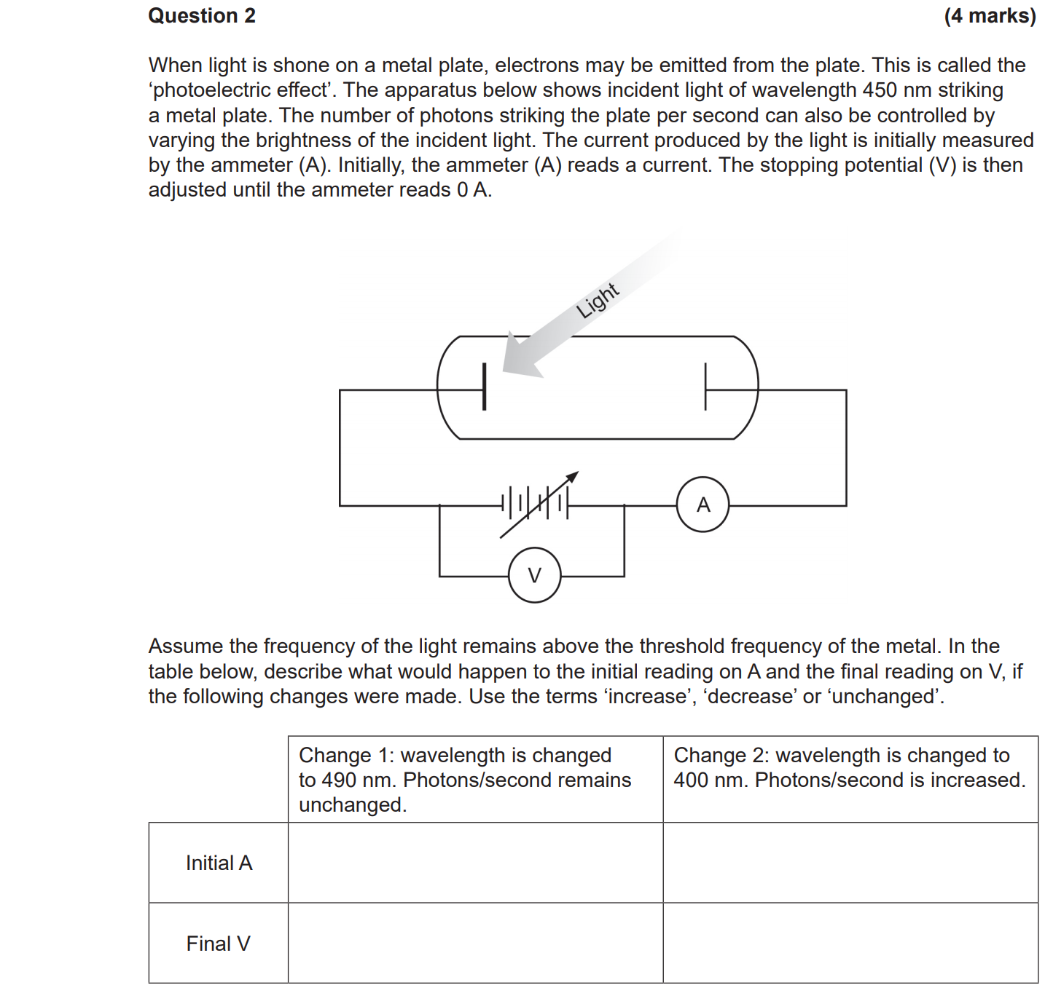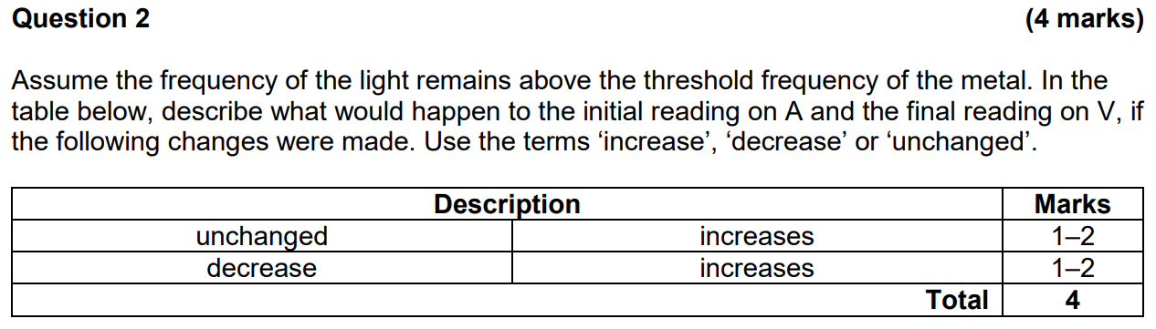

(I understand that V0 ∝ f but I don’t understand the “initial A” row. Isn’t photons/second the same as frequency?)

Because the electron is hot,